Meeting Minutes
January 16, 2023, 10:00am, Sid Rich 340

Welcome Kimberly Black
Call to order 10:31 Lexi, seconds Luke

Spiritual Formation Brett Gibson

Guest Speaker Peter Granick,
Chief Procurement Officer
- Employee meetings were held in December and ongoing where Aramark employees can apply for their positions I with Chartwells.
  - Tenure will stay with them, many will see raises. Some will get promotions, not all will get hired.
- Program launches 6/1/2024
- Timeline
  - 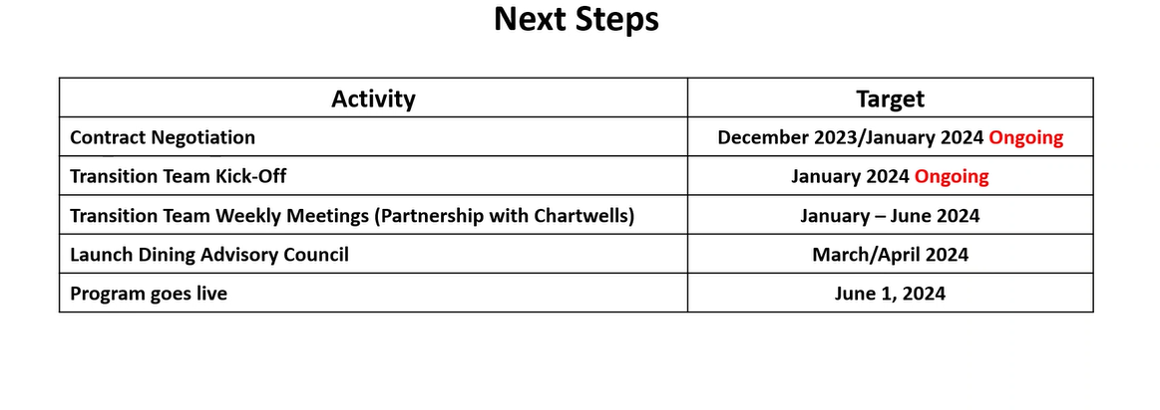

Old Business
- December Minutes Chelsea Derry
  - Daniel moves Luke seconds
- Ombudsperson Update Kimberly Black
  - Coming in February
- Staff Awards Application is live Kimberly Black
  - https://hr.web.baylor.edu/benefits-advantages/employee-recognition/staff-awards/outstanding-staff-award

New Business
- Spring Faculty Meeting Invitation Kimberly Black
  - January 23, 2024 3:00-4:30 Link forthcoming
- University Committee Updates Representatives
- Committee Work/Reports Committee Chairs

Staff Council Pins

January Birthdays

Adjourn
Motion to adjourn Luke Lexi seconds 11:21am

